Communications Styles matrix

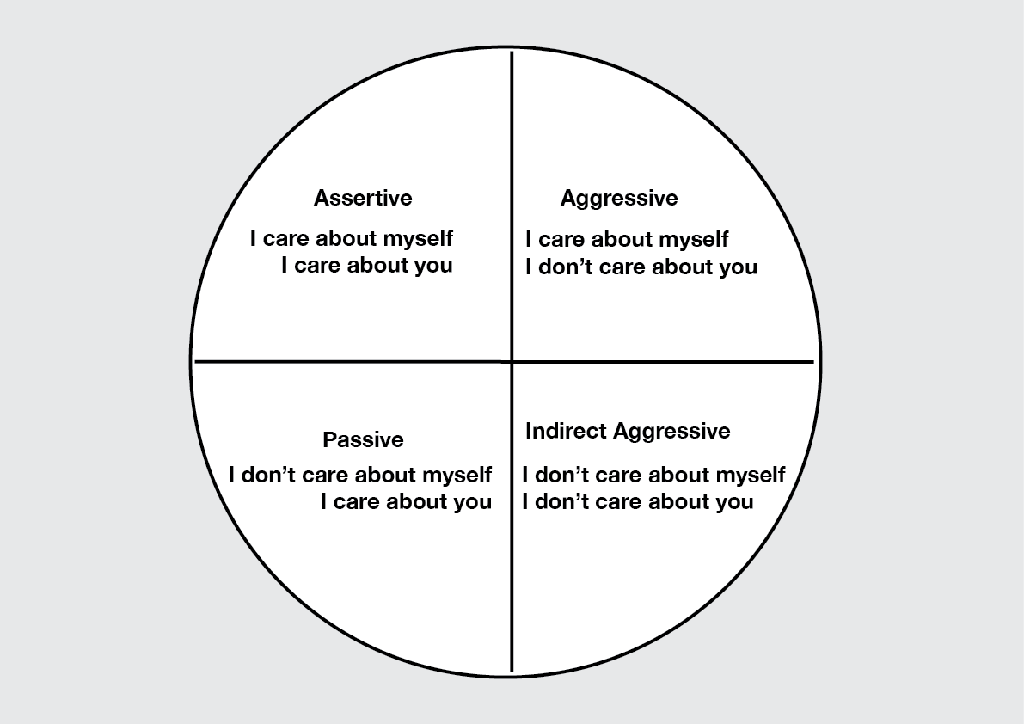

Behaviours
Aggressive | Assertive | Passive | Indirect aggressive
- Violent  - Hitting or physically harming people  - Threaten people  - Yelling  - Shouting  - Saying nasty things  - Being bitchy  - Putting other people down  - Being sarcastic  - Talking over or interrupting other people  - Doesn’t care what other people want | - Dealing with other people calmly  - Making compromises  - Stating your point of view calmly  - Acknowledging how the other person feels  - Working together to find a solution  - Value what other people think and feel as well as your own thoughts and feelings | - Ignoring the situation  - Avoiding conflict  - Assuming that you can’t do anything to improve a situation  - Just giving in to dominant people  - Afraid to say what you want  - Value other people’s thoughts and feelings but not your own | - Bitching behind people’s back  - Saying you’ll do something and not doing it  - Always turning up late to classes you don’t like

